1 | If you are not already signed up to the Member Portal, please follow these instructions:  - Navigate to the Member Portal.  - For portal login instructions, please navigate to: https://rmiportal.pericura.com/clientportal/public/PortalLoginInstructions.pdf

2 | - From the portal homepage, select the “Underwriting” tab and “Account” from the dropdown menu.  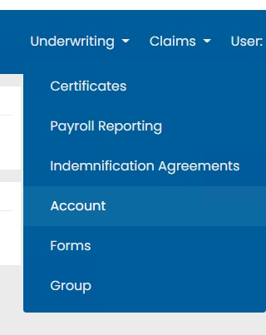

3 | - You will then be redirected to your Account Management Screen. On the right side, there is an “ACH Configuration” window. To set up a new account, select “Set Up.”  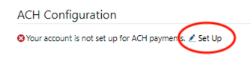

4 | - Enter your routing number, bank, and account number into the ACH Settings window and select “Done.”  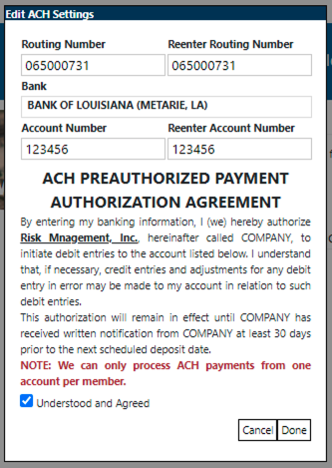

5 | - Once you have configured the ACH, a pop-up will appear with further instructions.  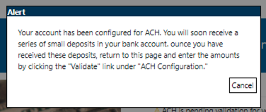

6 | - Your ACH status will then change to pending validation.  - Once the series of small deposits have appeared in your account, validate your account by selecting the pencil icon next to the word “Validate.” This is the final step in the account setup process.  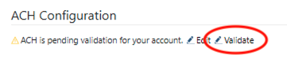

7 | - Enter the three deposited amounts into the “Validate ACH Settings” screen and select “Done.”  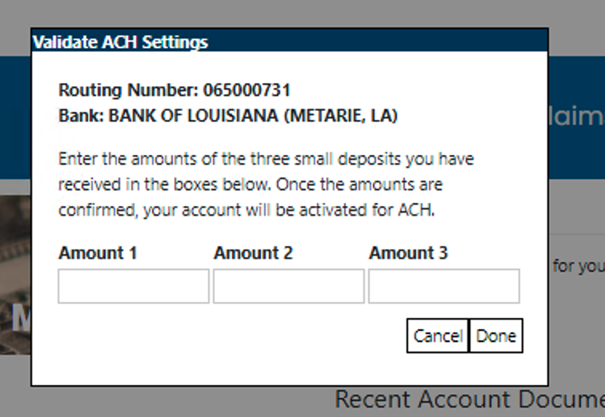

8 | - Once you have completed the validation instructions, your ACH Configuration will look like this:  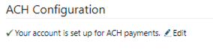

HELP! Something went wrong.
- I don’t have an account:

- Please reach out to the site administrator or request an account via https://rmiportal.pericura.com/clientportal/signup.aspx depending on your desired account type (member, provider, or attorney).

- I forgot my password:

  - Click the “Forgot Password” link at the https://rmiportal.pericura.com/clientportal/login.aspx login screen and enter your username. From there, a reset password link will be sent to your email.

- Something else is wrong:

  - If you believe something is wrong with your account, documentation, or your website interface is incorrect, please reach out to the site administrator for your organization or contact RMI and they will direct your issue to the appropriate team.

